* Hotplate di Logo DanBam (Sebagai refrensi saja tidak pakai gambarnya karena pakai mouse gambarnya)

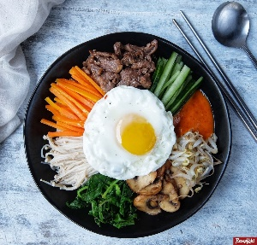

[**https://www.google.com/url?sa=i&url=https%3A%2F%2Fresepkoki.id%2Fresep%2Fresep-bibimbap%2F&psig=AOvVaw3m9nYlqeLXPXuxZnrpZkFD&ust=1622467655302000&source=images&cd=vfe&ved=0CAIQjRxqFwoTCOCp04i08fACFQAAAAAdAAAAABAX**](https://www.google.com/url?sa=i&url=https%3A%2F%2Fresepkoki.id%2Fresep%2Fresep-bibimbap%2F&psig=AOvVaw3m9nYlqeLXPXuxZnrpZkFD&ust=1622467655302000&source=images&cd=vfe&ved=0CAIQjRxqFwoTCOCp04i08fACFQAAAAAdAAAAABAX)

* Map Vector



<https://www.google.com/url?sa=i&url=https%3A%2F%2Fwww.pinterest.com%2Fpin%2F757801074779272333%2F&psig=AOvVaw3jJh9U0QfGp0LI0Fnr3dIr&ust=1622467028618000&source=images&cd=vfe&ved=0CAIQjRxqFwoTCIiU5Nux8fACFQAAAAAdAAAAABAD>

* Gambar makanan buat home page

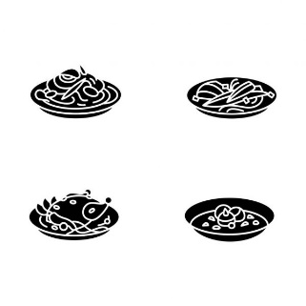

<https://st2.depositphotos.com/37265746/45270/v/600/depositphotos_452707342-stock-illustration-korean-food-glyph-icons.jpg>

* Youtube Logo



<https://www.google.com/url?sa=i&url=https%3A%2F%2Ftoppng.com%2Ffree-image%2Fyoutube-logo-transparent-png-pictures-transparent-background-youtube-logo-PNG-free-PNG-Images_163952&psig=AOvVaw2di8wJ93wuq_lLWwgoyVfj&ust=1622467444037000&source=images&cd=vfe&ved=0CAIQjRxqFwoTCMjf0qKz8fACFQAAAAAdAAAAABAJ>

* Insta logo



<https://www.google.com/url?sa=i&url=https%3A%2F%2Fwww.stickpng.com%2Fimg%2Ficons-logos-emojis%2Ftech-companies%2Fnew-black-instagram-logo-2020&psig=AOvVaw214MU0jDhSbRuTaF21rNp5&ust=1622467493502000&source=images&cd=vfe&ved=0CAIQjRxqFwoTCMDa1bmz8fACFQAAAAAdAAAAABAD>

* Twitter Logo



<https://www.google.com/url?sa=i&url=https%3A%2F%2Fwww.freepnglogos.com%2Fpics%2Ftwitter-logo-png&psig=AOvVaw2LLT5qY3x8yGQDMC8MTcnZ&ust=1622467611701000&source=images&cd=vfe&ved=0CAIQjRxqFwoTCODd1_Oz8fACFQAAAAAdAAAAABAD>

* Naengmeon

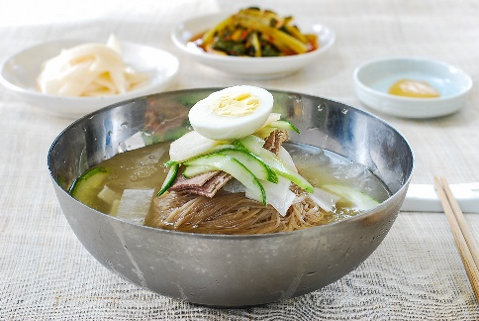

<https://www.google.com/url?sa=i&url=https%3A%2F%2Fwww.koreanbapsang.com%2Fnaengmyeon-cold-noodles%2F&psig=AOvVaw3rCQ-uKoSTjZCvVoq7I1u5&ust=1622464270542000&source=images&cd=vfe&ved=0CAIQjRxqFwoTCNDp07un8fACFQAAAAAdAAAAABAD>

* Sikhye

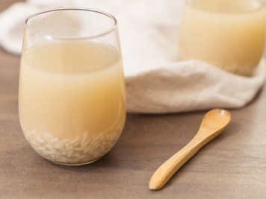

<https://www.google.com/url?sa=i&url=https%3A%2F%2Fwww.dreamers.id%2Farticle%2F86418%2Fmenikmati-minuman-khas-korea-yang-manis-dan-punya-manfaat-unik-sikhye&psig=AOvVaw1GtWMtRNYd1AwxKrMWF_6y&ust=1622464695449000&source=images&cd=vfe&ved=0CAIQjRxqFwoTCKCX44Op8fACFQAAAAAdAAAAABAD>

* Sundubu Jiggae

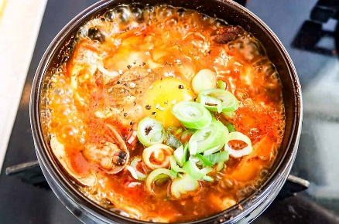

<https://www.google.com/url?sa=i&url=https%3A%2F%2Ffuturedish.com%2Fkorean-sundubu-paste-make-jjigae-in-5-min%2F&psig=AOvVaw10jso8xtnaLw8THTU0Tr4j&ust=1622464769856000&source=images&cd=vfe&ved=0CAIQjRxqFwoTCLCA7Kep8fACFQAAAAAdAAAAABAD>

* Bibimbap

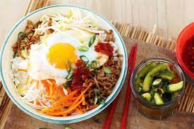

<https://www.google.com/imgres?imgurl=https%3A%2F%2Fimg.taste.com.au%2F-pKaSBAQ%2Fw720-h480-cfill-q80%2Ftaste%2F2016%2F11%2Fkorean-mixed-rice-bibimbap-100884-1.jpeg&imgrefurl=https%3A%2F%2Fwww.taste.com.au%2Frecipes%2Fkorean-mixed-rice-bibimbap%2F4097c152-82b0-4f44-8ef2-1f3071ee58de&tbnid=XnI774N8SAmv6M&vet=12ahUKEwinirmYxvHwAhXUCLcAHfOeAvYQMygAegUIARCaAQ..i&docid=rj1u_Do47MwXNM&w=720&h=480&q=bowl&hl=en-AR&safe=strict&ved=2ahUKEwinirmYxvHwAhXUCLcAHfOeAvYQMygAegUIARCaAQ>

* Dalgona Snack

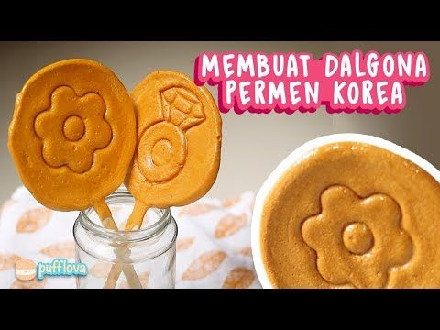

<https://www.google.com/url?sa=i&url=https%3A%2F%2Fid.pinterest.com%2Fpin%2F601371356473171300%2F&psig=AOvVaw1T9FKV3eOR8XeKuCs6O3Ck&ust=1622469786614000&source=images&cd=vfe&ved=0CAIQjRxqFwoTCMjUxP-78fACFQAAAAAdAAAAABAD>

* Hobajuk

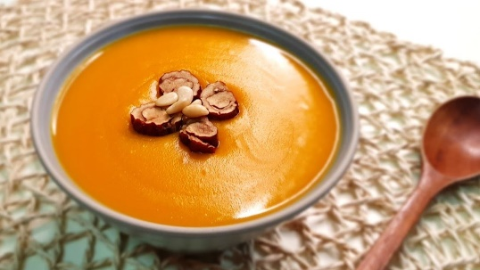

<https://www.google.com/imgres?imgurl=https%3A%2F%2Fi.ytimg.com%2Fvi%2FoIt1mm1QeB8%2Fmaxresdefault.jpg&imgrefurl=https%3A%2F%2Fwww.youtube.com%2Fwatch%3Fv%3DoIt1mm1QeB8&tbnid=O7hEPS8IJMF1TM&vet=12ahUKEwiMzc-fyfHwAhWLVn0KHTWTAmgQMygUegUIARDvAQ..i&docid=WEx9W5-sBju9gM&w=1280&h=720&q=hobakjuk&hl=en-AR&safe=strict&ved=2ahUKEwiMzc-fyfHwAhWLVn0KHTWTAmgQMygUegUIARDvAQ>

* Haemul Pajeon

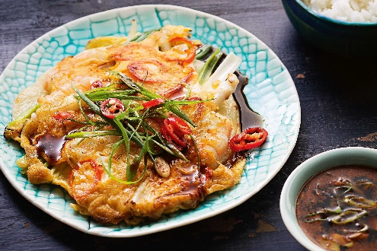

<https://www.google.com/imgres?imgurl=https%3A%2F%2Fimg.taste.com.au%2F0NVROZvr%2Ftaste%2F2016%2F11%2Fkorean-seafood-pancake-103181-1.jpeg&imgrefurl=https%3A%2F%2Fwww.taste.com.au%2Frecipes%2Fkorean-seafood-pancake%2F8f1c8dd2-1791-45f5-8052-9c70448323f8&tbnid=T-NgiXEVJnt5BM&vet=12ahUKEwiz0tuIyvHwAhWRzHMBHS9gBNYQMygNegUIARDpAQ..i&docid=7PvGwwcwyPTk_M&w=3000&h=2000&q=haemul%20pajeon%20(seafood%20vegetable%20pancake)&hl=en-AR&safe=strict&ved=2ahUKEwiz0tuIyvHwAhWRzHMBHS9gBNYQMygNegUIARDpAQ>

* Japchae

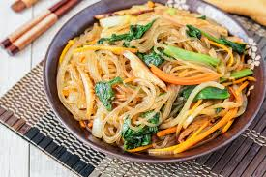

<https://www.google.com/imgres?imgurl=https%3A%2F%2Ftarasmulticulturaltable.com%2Fwp-content%2Fuploads%2F2013%2F03%2FJap-Chae-Korean-Stir-Fried-Sweet-Potato-Noodles-2-of-3.jpg&imgrefurl=https%3A%2F%2Ftarasmulticulturaltable.com%2Fjap-chae-korean-stir-fried-sweet-potato-noodles%2F&tbnid=prvgxcZL3UNcdM&vet=12ahUKEwjakfvdy_HwAhWMTCsKHVoMBikQMygUegUIARCHAg..i&docid=x3nPvHKWa3IQIM&w=1300&h=865&q=japchae%20(stir-fried%20noodles)&safe=strict&ved=2ahUKEwjakfvdy_HwAhWMTCsKHVoMBikQMygUegUIARCHAg>

* Bulgogi

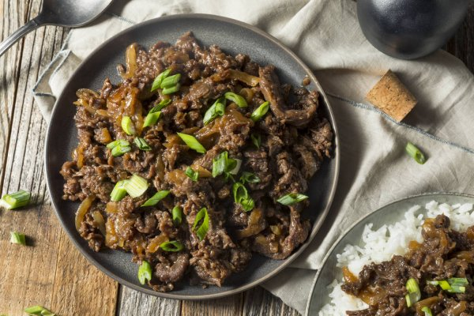

<https://www.google.com/imgres?imgurl=https%3A%2F%2Fst3.depositphotos.com%2F1692343%2F18629%2Fi%2F600%2Fdepositphotos_186297030-stock-photo-homemade-barbecue-korean-beef-bulgogi.jpg&imgrefurl=https%3A%2F%2Fdepositphotos.com%2Fstock-photos%2Fbulgogi-rice-bowl.html&tbnid=9CLOQYqJ8wdC7M&vet=12ahUKEwijkYyYzPHwAhW9i0sFHRGuDB0QMygAegUIARChAQ..i&docid=oUlIPORIvHawSM&w=600&h=400&itg=1&q=bowl&hl=en_GB&safe=strict&ved=2ahUKEwijkYyYzPHwAhW9i0sFHRGuDB0QMygAegUIARChAQ>

* Samgyetang

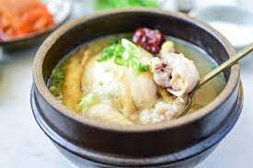

<https://www.google.com/imgres?imgurl=https%3A%2F%2Fwww.koreanbapsang.com%2Fwp-content%2Fuploads%2F2018%2F08%2FDSC_5131-2-1.jpg&imgrefurl=https%3A%2F%2Fwww.koreanbapsang.com%2Fsamgyetang%2F&tbnid=zxtTMNj7d5AyQM&vet=12ahUKEwjO34rdzPHwAhWUKSsKHeSDBCQQMygAegUIARCTAQ..i&docid=mxk8ECvRQuDPOM&w=3008&h=2008&q=samgye%20tang&hl=in&safe=strict&ved=2ahUKEwjO34rdzPHwAhWUKSsKHeSDBCQQMygAegUIARCTAQ>

* Food Vector

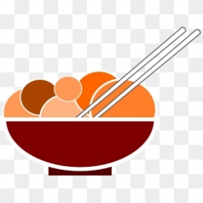

<https://www.google.com/imgres?imgurl=https%3A%2F%2Fo.dlf.pt%2Fdfpng%2Fsmallpng%2F570-5700525_cooking-clipart-cookery-tool-chinese-food-animation-png.png&imgrefurl=https%3A%2F%2Fwww.dlf.pt%2Fddetail%2FTioboTR_cooking-clipart-cookery-tool-chinese-food-animation-png%2F&tbnid=dg2MC6sWzw6fHM&vet=12ahUKEwih5bfOyvHwAhWqNrcAHbKWDiEQMygAegUIARCTAQ..i&docid=E6BIN6JnCUbxtM&w=280&h=280&q=chinese%20food%20animation&hl=en_GB&safe=strict&ved=2ahUKEwih5bfOyvHwAhWqNrcAHbKWDiEQMygAegUIARCTAQ>

* Drink Vector



<https://www.google.com/url?sa=i&url=https%3A%2F%2Ffavpng.com%2Fpng_view%2Fbeverage-vector-cocktail-wine-fizzy-drinks-alcoholic-drink-png%2FtMhMzHkd&psig=AOvVaw0GQ12axOjp7i-FMUF4Cx6Q&ust=1622470278488000&source=images&cd=vfe&ved=0CAIQjRxqFwoTCIjUg-y98fACFQAAAAAdAAAAABAM>

* Map

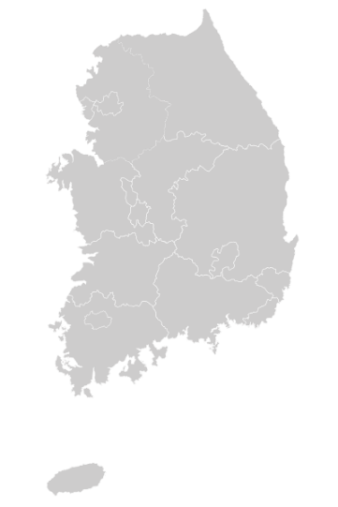

<https://upload.wikimedia.org/wikipedia/commons/thumb/d/dc/Map_of_South_Korea-blank.svg/400px-Map_of_South_Korea-blank.svg.png>

* Gambar Background untuk About Us

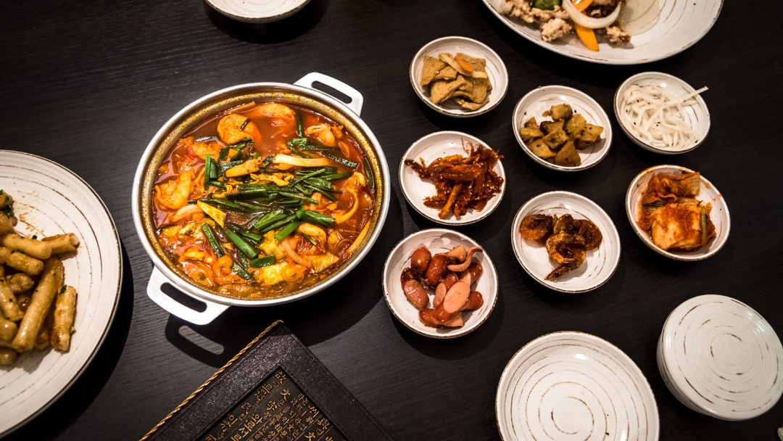

<https://kayakuliner.com/wp-content/uploads/2018/08/46ed6c12fadce57468fe1a9437cf2cd7.jpg>

* Resto 1

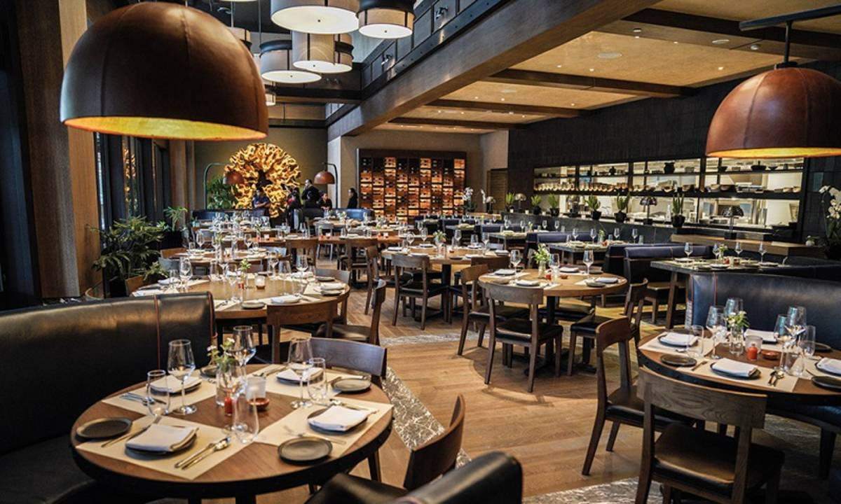

<https://image.cermati.com/q_70,w_1200,h_800,c_fit/szkdxemfqkbz0y1jozgh>

* Resto 2

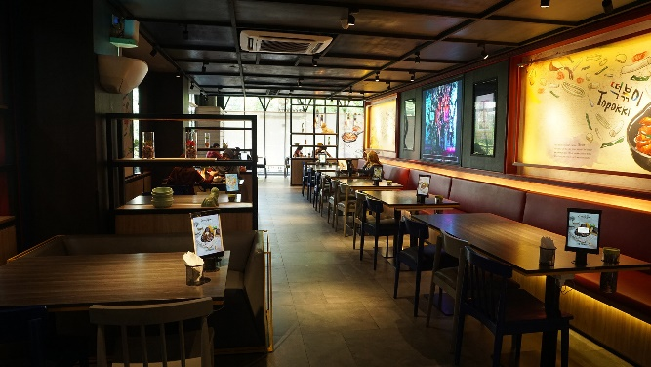

<https://www.minews.id/wp-content/uploads/2020/11/MUJIGAE-.-COM.jpg>

* Resto 3

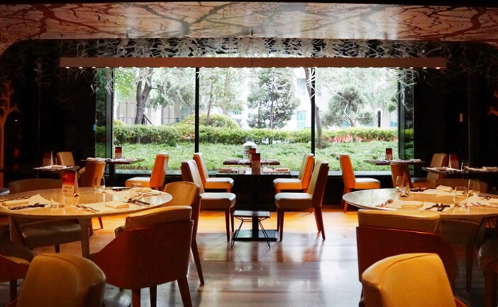

<https://www.visitkorea.or.id/uploads/media/images/2019-01-09/2516929_image_1.jpg>